**Jenkins assignment no- 2:** Create a git repository with three branches 2023Q1, 2023Q2, 2023Q3 each branch has its own index.html file. Create 3 jobs for three branches, run each job and website should be deploy on our httpd server with different code for different job:

**STEP 1:** First of all, I have setup a public git repository as httpd-repo.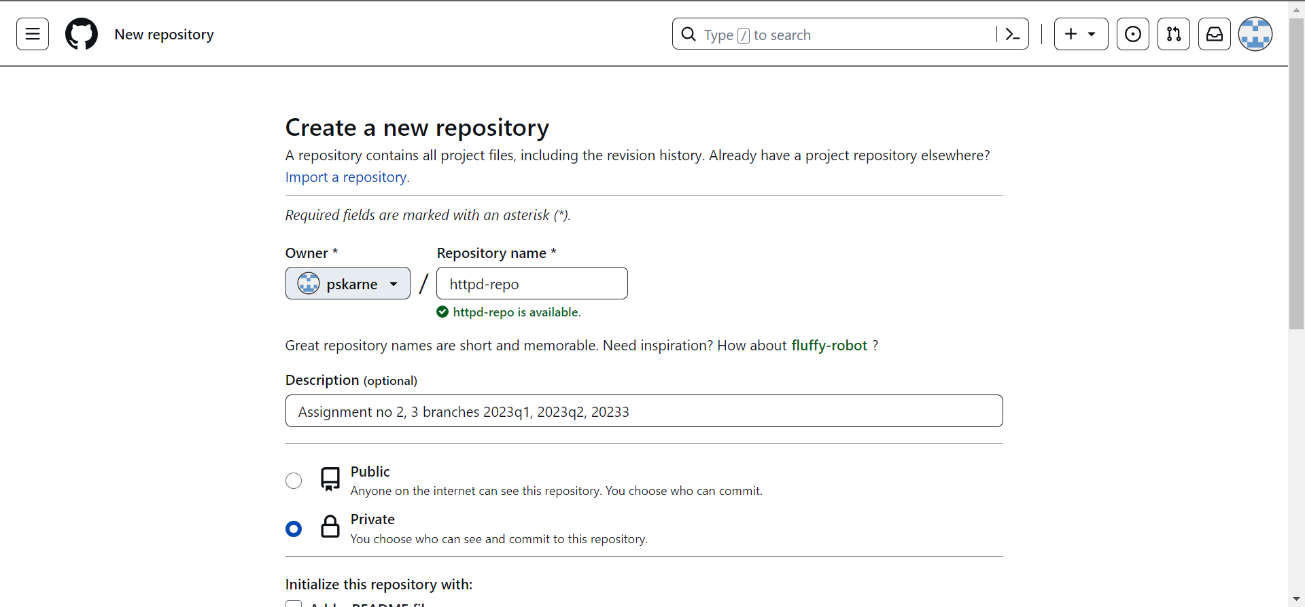

**STEP 2:** Cloned git repository on local machine.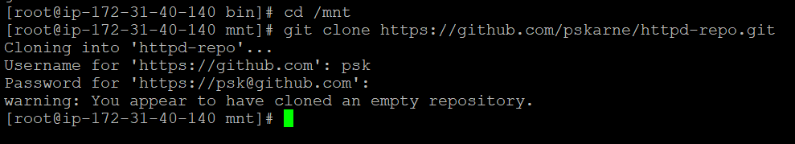**STEP 3:** Created 3 release branches for first 3 quarter release- 2023Q1, 2023Q2, 2023Q3 and pushed 3 branches to git repository. Branching strategy used- **“Latest code in master”**.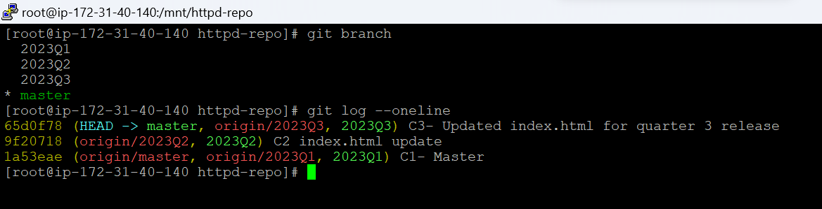

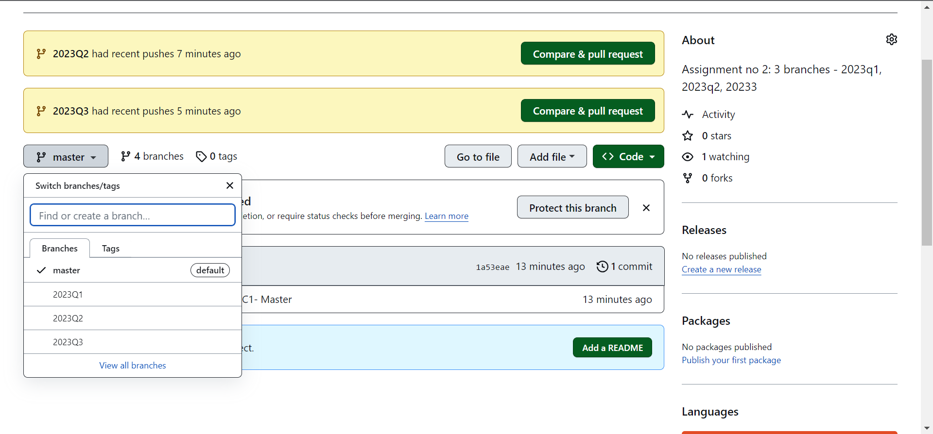

**STEP 4:** After that I’ve created 3 new jobs as 2023Q1, 2023Q2, 2023Q3:

**JOB:** 2023Q1

**Discard old builds:** Enabled

**Days to keep old build:** 1

**Max # of builds to keep:** 4

**Git:** Selected

**Repository URL:** <https://github.com/pskarne/httpd-repo.git>

**Credentials:** none (Repository is public)

**Branch Specifier:** */2023Q1

**Delete workspace before build start:** Selected

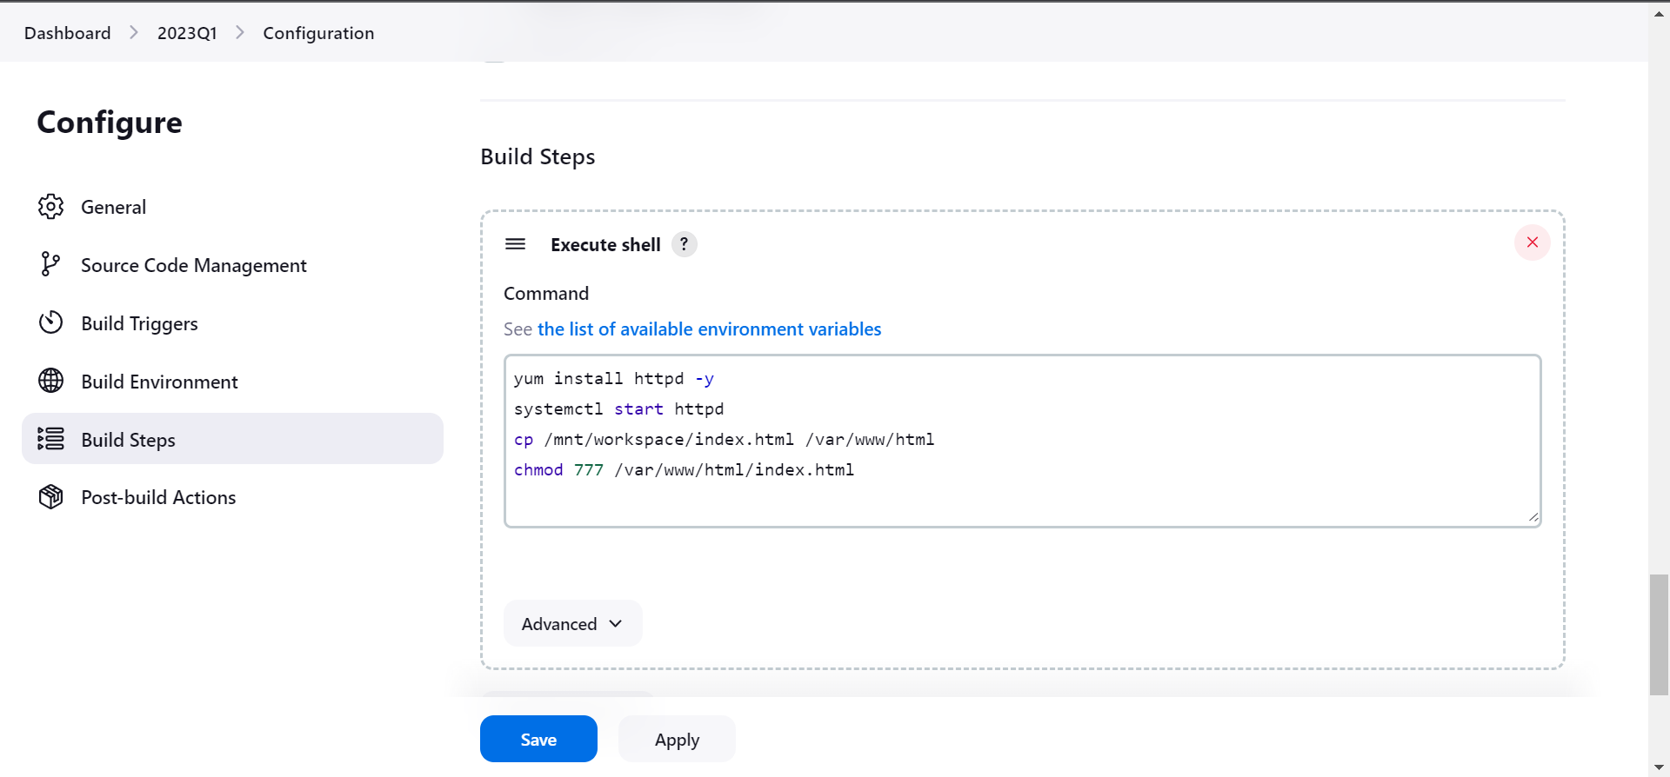

**BUILD RESULT AFTER RUNNING JOB 2023Q1**

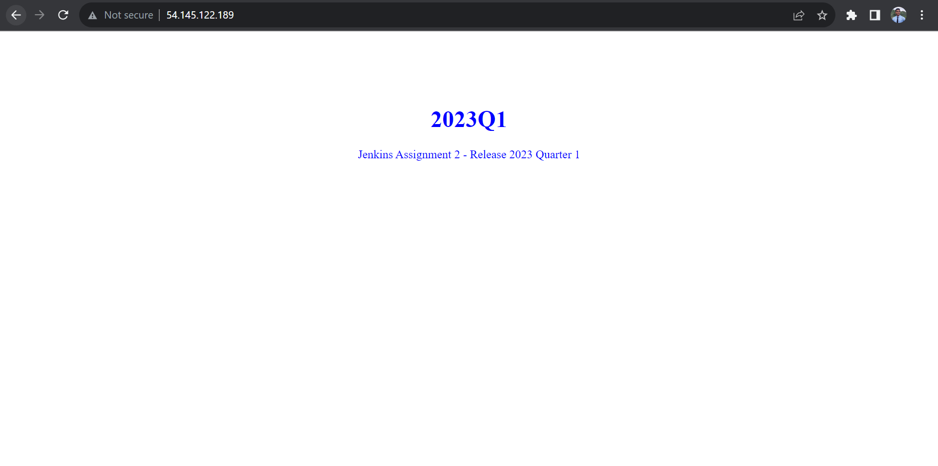

**JOB:** 2023Q2

**Discard old builds:** Enabled

**Days to keep old build:** 1

**Max # of builds to keep:** 4

**Git:** Selected

**Repository URL:** <https://github.com/pskarne/httpd-repo.git>

**Credentials:** none (Repository is public)

**Branch Specifier:** */2023Q2

**Delete workspace before build start:** Selected



**BUILD RESULT AFTER RUNNING JOB 2023Q2**

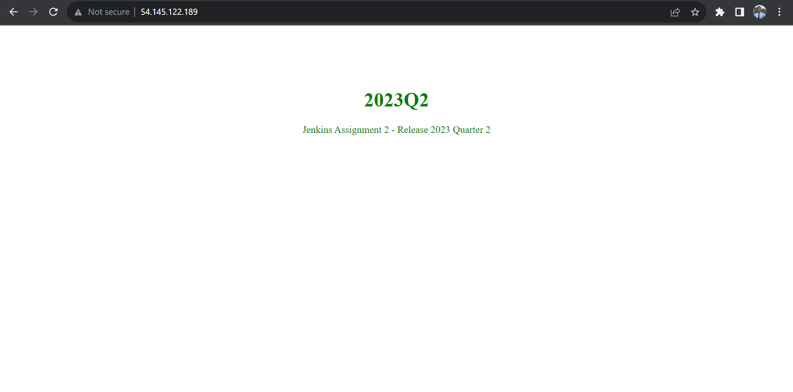

**JOB:** 2023Q3

**Discard old builds:** Enabled

**Days to keep old build:** 1

**Max # of builds to keep:** 4

**Git:** Selected

**Repository URL:** <https://github.com/pskarne/httpd-repo.git>

**Credentials:** none (Repository is public)

**Branch Specifier:** */2023Q3

**Delete workspace before build start:** Selected



**BUILD RESULT AFTER RUNNING JOB 2023Q3**

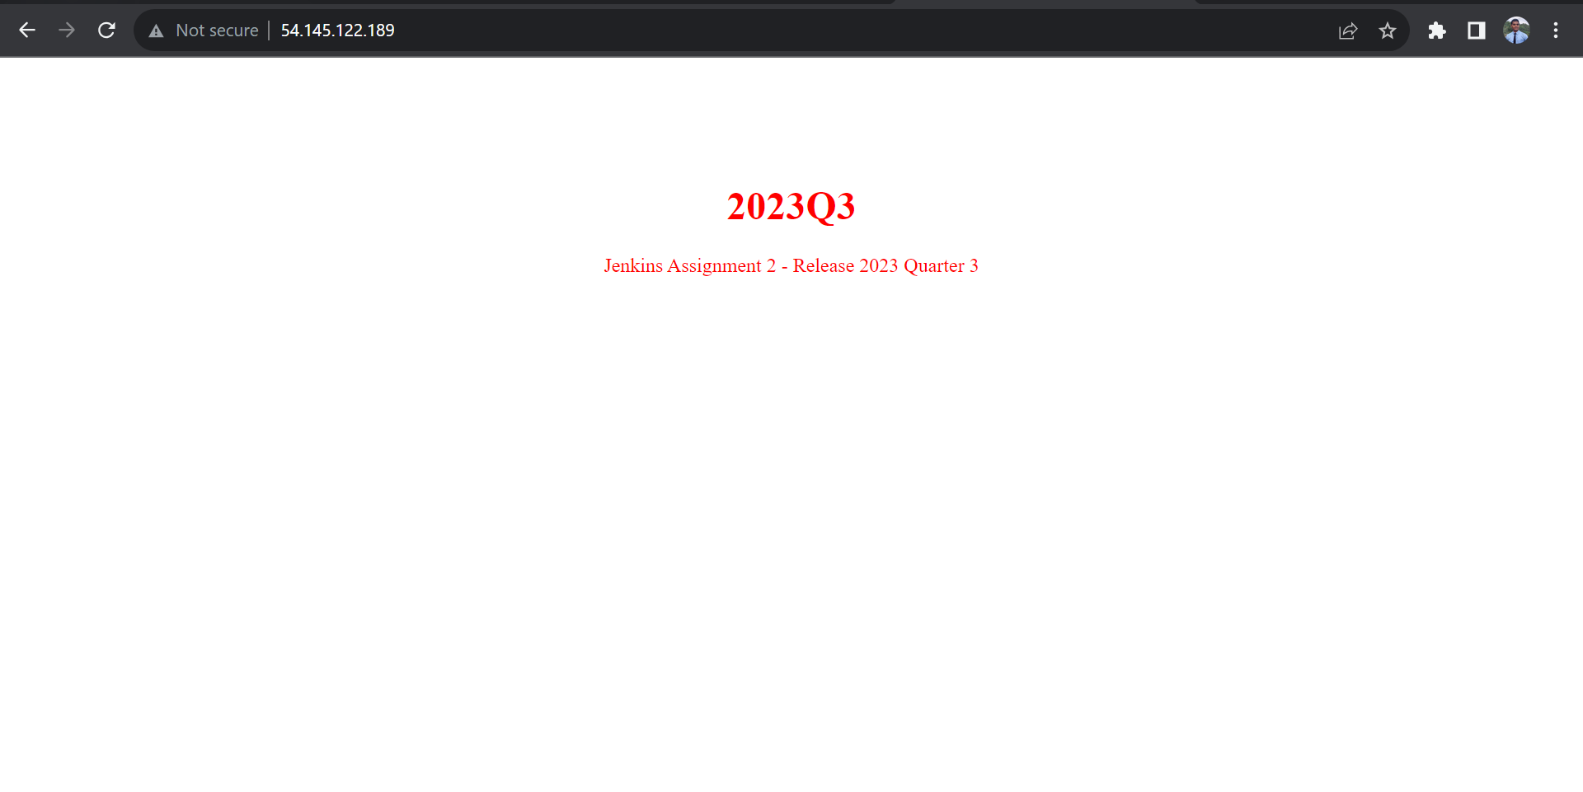

**Successfully completed an assignment no 2:**

